**DSA Assignment – 24th June**

**Name – Karan Joshi**

**Roll No. – 23/11/EC/036**

**Leetcode Id – Karan_Joshi068048**

**Geeksforgeeks Id – wwwjoshikaran3424**

**Github Repo Link -** [**https://github.com/KaranJoshi101/urban-octo-robot/**](https://github.com/KaranJoshi101/urban-octo-robot/)

DSA-Section -

Question 1: Reverse Linked List

Code:

class Node:

def __init__(self,x):

self.val = x

self.next = None

class LinkedList:

def __init__(self):

self.head = None

def insert_at_beg(self,x):

node = Node(x)

node.next = self.head

self.head = node

def insert_at_end(self,x):

if self.head == None:

self.head = Node(x)

else:

save = self.head

while save.next:

save = save.next

save.next = Node(x)

def insert_at_ind(self,x,i):

if i==0:

self.insert_at_beg(x)

prev = None

save = self.head

while save and i>1:

prev = save

save = save.next

i-=1

if save:

nextnode = save.next

save.next = Node(x)

save.next.next = nextnode

else:

prev.next = Node(x)

def delete_at_beg(self):

if self.head:

self.head = self.head.next

def delete_at_end(self):

if self.head:

save = self.head

prev = None

while save and save.next:

prev = save

save = save.next

if prev:

prev.next = None

def delete_at_ind(self,i):

if i==0:

self.delete_at_beg()

save = self.head

while i>1:

save = save.next

i-=1

save.next = save.next.next

def delete_first_occur(self,x):

if self.head.val==x:

self.head = self.head.next

save = self.head

prev = None

while save and save.val!=x:

prev = save

save = save.next

if save:

prev.next = save.next

def display(self):

save = self.head

print("Elements of Linked List: [",end=" ")

while save:

print(save.val,end=" ")

save = save.next

print(']')

l = LinkedList()

l.insert_at_beg(5)

l.display()

l.insert_at_ind(1,3)

l.display()

l.insert_at_end(8)

l.display()

l.insert_at_ind(3,1)

l.display()

l.delete_at_end()

l.display()

l.delete_at_ind(1)

l.display()

l.delete_at_beg()

l.display()

l.delete_at_beg()

l.display()

l.insert_at_beg(91)

l.insert_at_end(23)

l.insert_at_beg(54)

l.insert_at_ind(17,3)

l.insert_at_beg(1)

l.insert_at_beg(87)

l.insert_at_end(23)

l.display()

l.delete_first_occur(23)

l.display()

l.delete_first_occur(100)

l.display()

Screenshot:

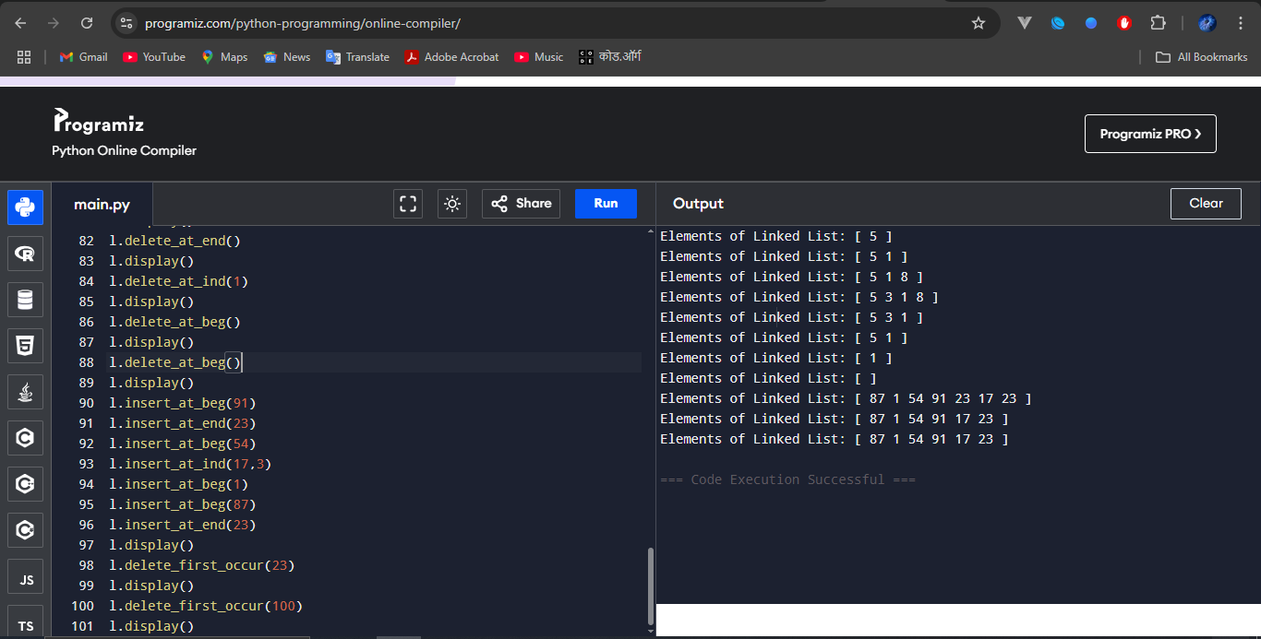

Question 2: Delete a Node in Singly Linked List

Platform: GeeksforGeeks

Problem Link: <https://www.geeksforgeeks.org/problems/delete-a-node-in-single-linked-list/1>

Submission Screenshot:

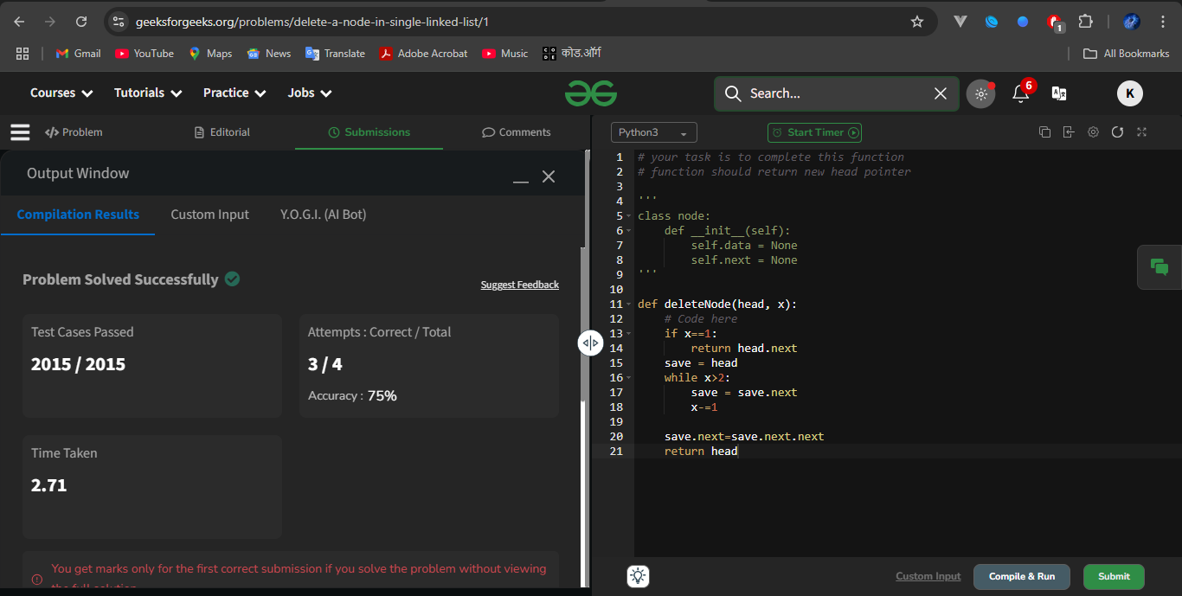

Question 3: Find Middle

Platform: LeetCode

Problem Link: <https://leetcode.com/problems/middle-of-the-linked-list/description/>

Submission Screenshot:

